

NATIONAL UNIVERSITY OF COMPUTER AND
EMERGING SCIENCES

PROGRAM: SOFTWARE ENGINEERING

OPERATING SYSTEMS LAB

LAB TASK- 02

SUBMITTED BY:

Name: Ahmed Ali

Roll No: 22P-9318
Section: BS(SE)-5B

INSTRUCTOR NAME: Sir Saad Ahmed

A DEPARTMENT OF COMPUTER SCIENCE

1. What is Sudo:
`sudo` stands for "superuser do."
It's a command used in Linux operating systems to allow a permitted user to execute a command with the security privileges of another user, usually the superuser (root).

→ Essentially, it lets you perform tasks that require higher permissions, like installing software or modifying system files.
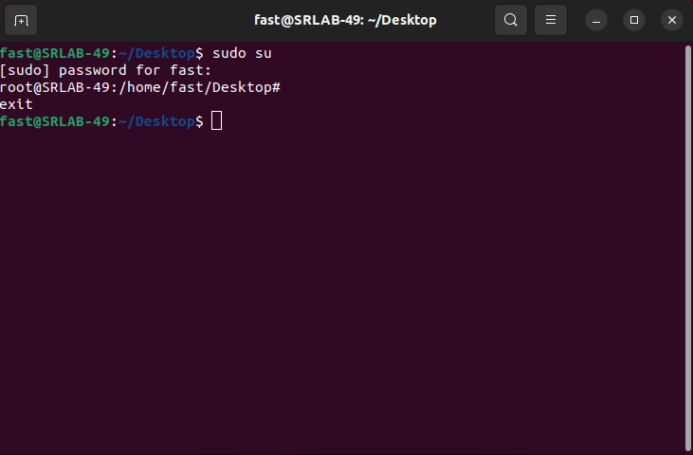
You can see after typing command sudo su, your pc asked password, after entering password you are now working as root user.
→ You can also go to root-user by sudo -i and for leaving root user simply type exit or press CTRL+D

2. What is ls command:

The `ls` command is used in Linux operating systems to list the files and directories in a directory.
→ It's a way to see what's inside a folder.
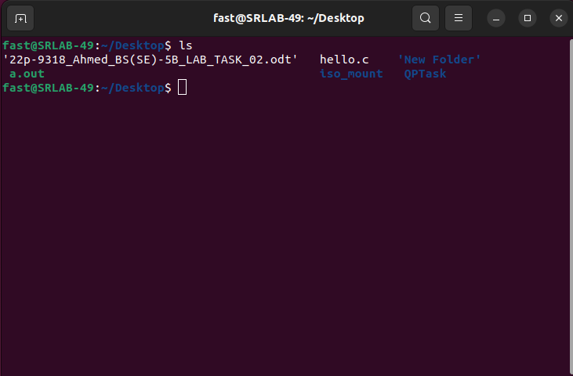
What is ls command:
You can see by entering ‘‘ls’’ command all the folders and files inside Desktop directory appears

You can Type the command “ls --help” and a list of commands that can be used along “ls command”.
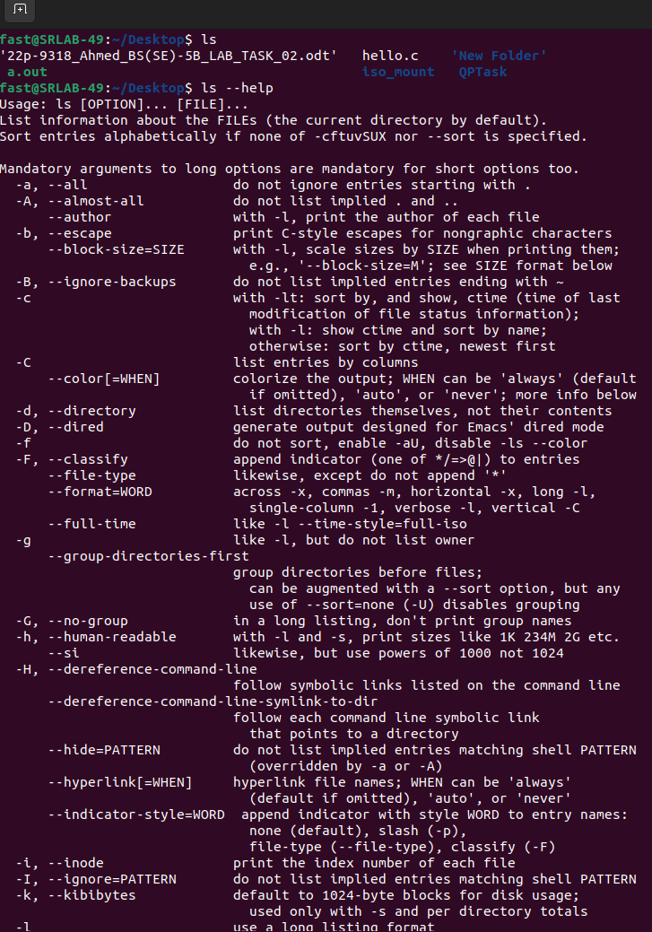

We will see some of these commands uses

1) Like typing “ls -1” will list one file per line. Avoid usage of '\n'.
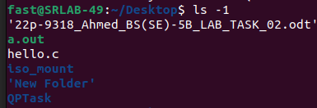

2) Similarly entering command “ls -a” will sow all the files and folders even the hidden files and folders will also be shown.
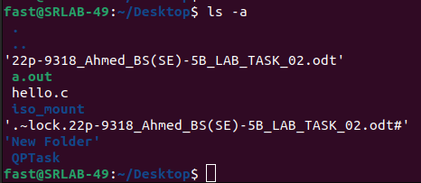

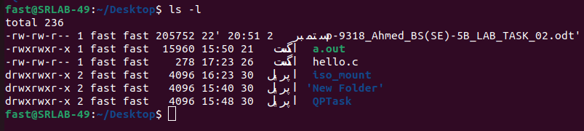
3) If you enter the “ls -l” command in Ubuntu It provides a detWhat is ls command:ailed listing of files and directories in the current directory.
→ It shows additional information such as file permissions, number of links, owner, group, size, and the last modified date and time for each item.

4) The “ls -d” command in Ubuntu lists directories themselves rather than their contents.
→ For example, if you use ls -d */, it will show the directories in the current location without listing their contents.
→ This can be useful if you want to see the directory names without expanding into them.
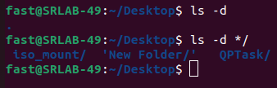

You can see by entering only ls -d command it shows only relative directory while using ls -d */ command will also show only the directories inside it.

5) The ls -n command in Linux operating systems lists directory contents with numeric user and group IDs instead of names.
→ This is useful in scenarios where you might need to see the numeric values of ownership instead of resolving them to user or group names.

Here's a breakdown of the ls -n output:
- The command displays a list of files and directories.
- For each file or directory, it shows details such as permissions, number of links, numeric user ID (UID), numeric group ID (GID), file size, modification date, and file name.
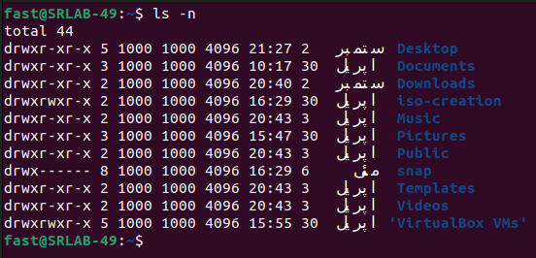
In this output:
- 1000 is the numeric UID of the file owner.
- 1000 is the numeric GID of the group.
This can be useful for scripting or when managing systems where user and group names might not be readily available or when working with systems where user and group names have not been properly set up.

3. What is cd command:

The cd command in Linux operating systems stands for "change directory" and is used to navigate between directories in the filesystem.

cd Command
- Usage: cd [directory]
- Function: Changes the current working directory to the specified [directory].
- Example: cd Documents changes the current directory to Documents, assuming it's a subdirectory of the current directory.

cd ..
- Usage: cd ..
- Function: Moves up one level in the directory hierarchy.
- Example: If you are in /home/user/Documents and run cd .., you will move up to /home/user.

cd /
- Usage: cd /
- Function: Changes the current directory to the root directory of the filesystem.
- Example: If you are in /home/user/Documents and run cd /, you will move to the root directory (/).
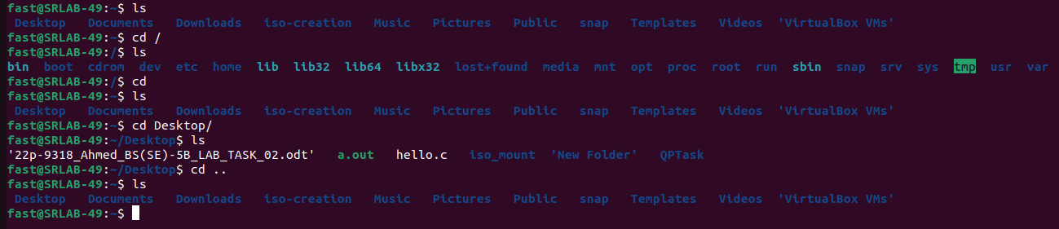

Summary of Uses
- cd [directory]: Navigate to a specific directory.
- cd ..: Move up one directory level.
- cd /: Move to the root directory of the filesystem for coming back simply enter cd.

4. What is pwd command:
The pwd command stands for "print working directory" and is used in Linux operating systems to display the current working directory.

Usage
- Command: pwd
- Function: Outputs the absolute path of the directory you are currently in.
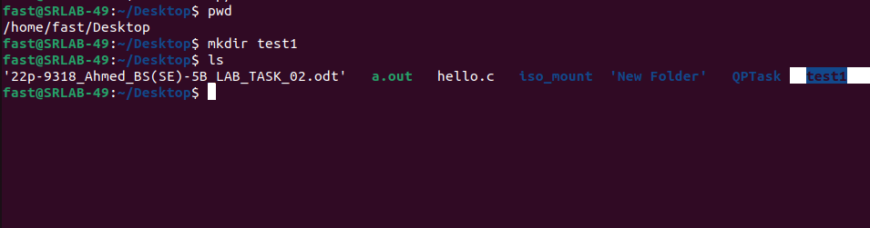

Example
If you are in the directory /home/fast/Desktop and you run the command pwd, it will output: /home/fast/Desktop

Uses of pwd
Confirm Current Directory: Helps you verify your current location in the filesystem, which is useful for ensuring you are in the correct directory before executing further commands.
- Script Debugging: In scripts, pwd can be used to record the current directory, especially when navigating directories programmatically. This can help in debugging or logging directory paths.
- Path Reference: Useful when you need to reference or work with absolute paths, particularly when moving files, running programs, or setting environment variables.
- Navigation Aid: Helps in visualizing your location in the filesystem, making it easier to understand the context of your work, especially when dealing with deep directory structures.
5. What is adduser command:
adduser : Addition of new user.
The `adduser` command in Ubuntu is used to create a new user account on the system.
→ It sets up the user’s home directory and initial configuration files, and can also prompt you to enter additional information like the user’s full name.
→ For adding user you first need to go to root user type command sudo su or sudo -i.
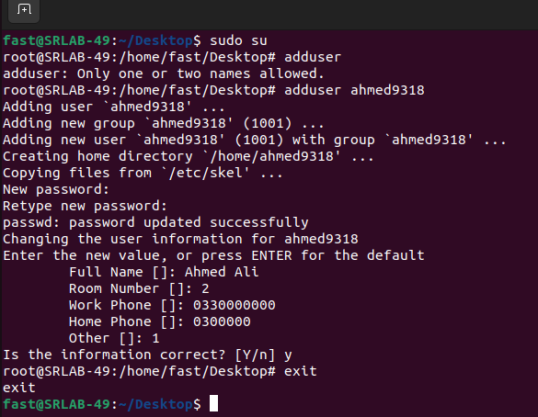

first go to root user by entering command sudo su
enter the password
then type command adduser
again type adduser[name of user]
Enter password for new user
Confirm password for new user
You will be asked some information
fill it up and after filling you will be asked;
Is the information correct enter y.

6. What is passwd command:
The `passwd` command in Ubuntu is used to change a user’s password.
→ It can be used to update your own password or, with appropriate permissions, to change the passwords of other users.
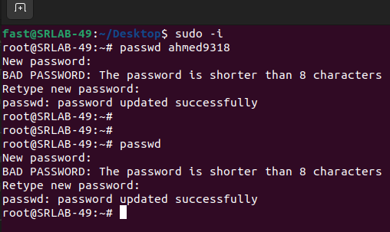
What is passwd command:
First You need to go to root user for that I used sudo -i command.
→ Then if You enter only passwd command it will ask you to enter the new password it means it is changing the password of current user.
→ For changing password of other user go to root user for that I used sudo -i command;
Type passwd[name of other user] and hit enter you will be asked to enter new password.

7. What is ifconfig command:
ifconfig: Used to configure and display network interfaces on a system. It shows information about network interfaces like IP addresses and network statistics.
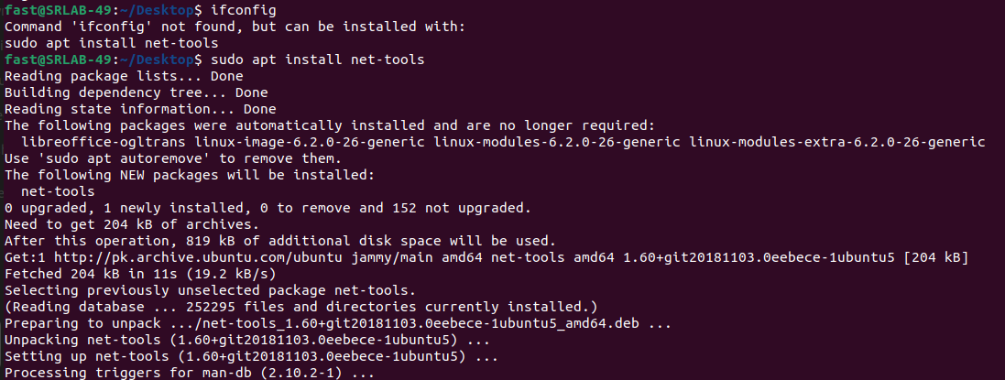

If this command is not working type sudo apt install net-tools and try again

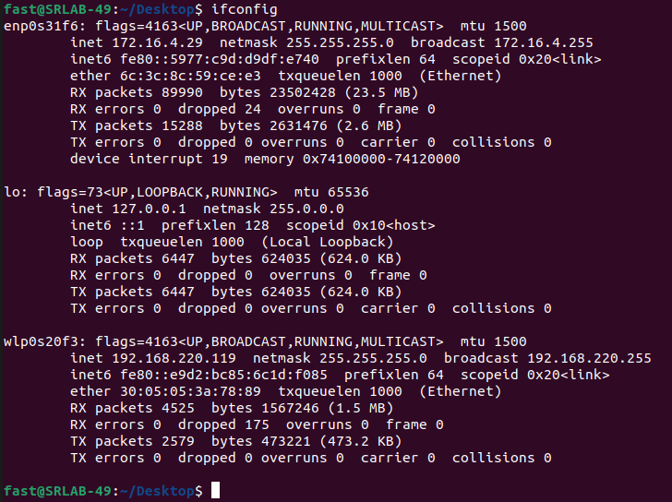
iwconfig: Used to configure and display wireless network interfaces. It shows details about wireless network settings such as SSID, frequency, and signal strength.
Just type iwconfig in terminal.

Sudo apt update:
The `sudo apt update` command in Ubuntu updates the local package index with the latest information from the software repositories.
→ It helps ensure that you have the most current information about available packages and their versions before installing or upgrading software.

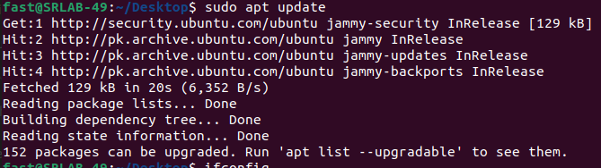

While installing sudo apt install tree show you directories and files with in a directory in hierarichal structures

